OUTREACH SCHOOLS EXAMINATION BOARD
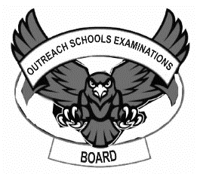
MID TERM III EXAMINATION 2023
BABY CLASS: (3 – 4 YEARS)
LEARNING AREA 5: LANGUAGE DEVELOPMENT II

My name is: ……………………………………………………………….
My School is: …………………………………….………………………..
I am in: ………………………………..…………………………….…………………..
I. Match a vowel to the friend and draw.
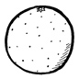
a __________
e __________
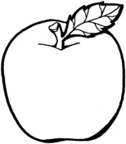
i __________
o _________
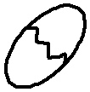
u __________

2. Circle the correct vowels for the picture.
 | i e
 | u o
 | e a
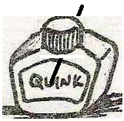 | u i
 | o a

3. Form words and read.
i-t = ___________
a -n = ___________
i-n = ____________
o-n = ____________
a-m = ___________
4. Read the words.
an at it
5. Shade this animal for sound s.
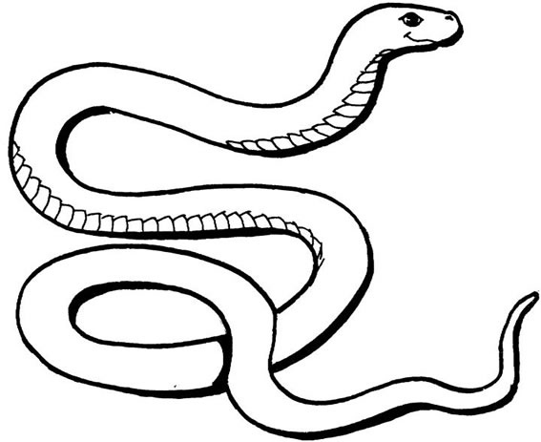

6. Copy and write.
m m m m m
t t t t t
r r r r r

END

