273/1
S.3 GEOGRAPHY
END OF YEAR PAPER NOV 2024
2¾ hours

ALLIED GEOGRAPHY TEACHERS’ EXAMINATION BOARB 2024
UCE AGTEB END OF YEAR EXAM 2024
GEOGRAPHY
S.3
Paper 1
2 hours 45 minutes

INSTRUCTIONS TO CANDIDATES:
- This paper has two sections; A and B. It has six examination items.
- Section A has two compulsory items.
- Section B has two parts; I and II. Answer one item from each part.
- Answer four items in all.
- You may use diagrams, where applicable, to illustrate your answers.
- Any additional item(s) answered will not be scored
- All answers must be written in the answer booklet(s) provided

SECTION A
Answer both items in this section.
ITEM 1: Map Skills
For this item use the EAST AFRICA, 1:50,000 (UGANDA): NAKASONGOLA, map extract Sheet 50/2 Series Y732 and Edition 1 − USD to respond to the tasks.
Your school has scheduled a study tour to Nakasongola study area located at latitudes between 1⁰15′ to 1⁰20′. The place has many developments of physical and human features which can attract tourists if are well developed. These include relief, climate, vegetation and human settings. The climate is more or less savanna with heavy rainfall, long dry times, and hot temperatures leading different land uses.
During the pilot study, the bookings were paid in Nakasongola town at 400448 in Wabinyonyi Sub County where the tour camp to be stationed during their study tour. Students are asked to carry out literature study and other pre-activities in the preparations.
Accordingly, students are to make a report about their study tour to be used in the development of the area about as the local government plans stand in the next 10 year development goal.
Task:
(a) (i) Students are to travel from near road junction at 406466 along loose surface road to Katambwa in North of Nakasongola, guide them on the distance and direction of the of the place.
(ii) Identify the problems students are likely to face in their tour camp and in the surrounding 2 kilometer distance.
(4 scores)
(b) Illustrate the relief section of the area from main truck (400431) to Kabasike village hill (400500) to locate the camp station, physical and human features.
(4 scores)
(c) Using the information in the scenario and the map extract, advise the people in Nakasongola on the most suitable human activities carried out due to the nature of the relief in the area.
(4 scores)

Item 2: Photographic Skills
In the last publication by the Ministry of Energy Mineral management and development, indicated the increase in the use of the traditional tools in the mining of the existing minerals in local communities shown in the photograph. People involved in the mining explains several gains including supplements to their incomes from other activities.
However, the ministry has a plan to attract foreign companies to invest in commercial mining and mineral processing to achieve both local and national development and benefits. During your school local tourism in which you participated in, people reported many worries that foreign companies might not benefit the area, but instead cause several losses
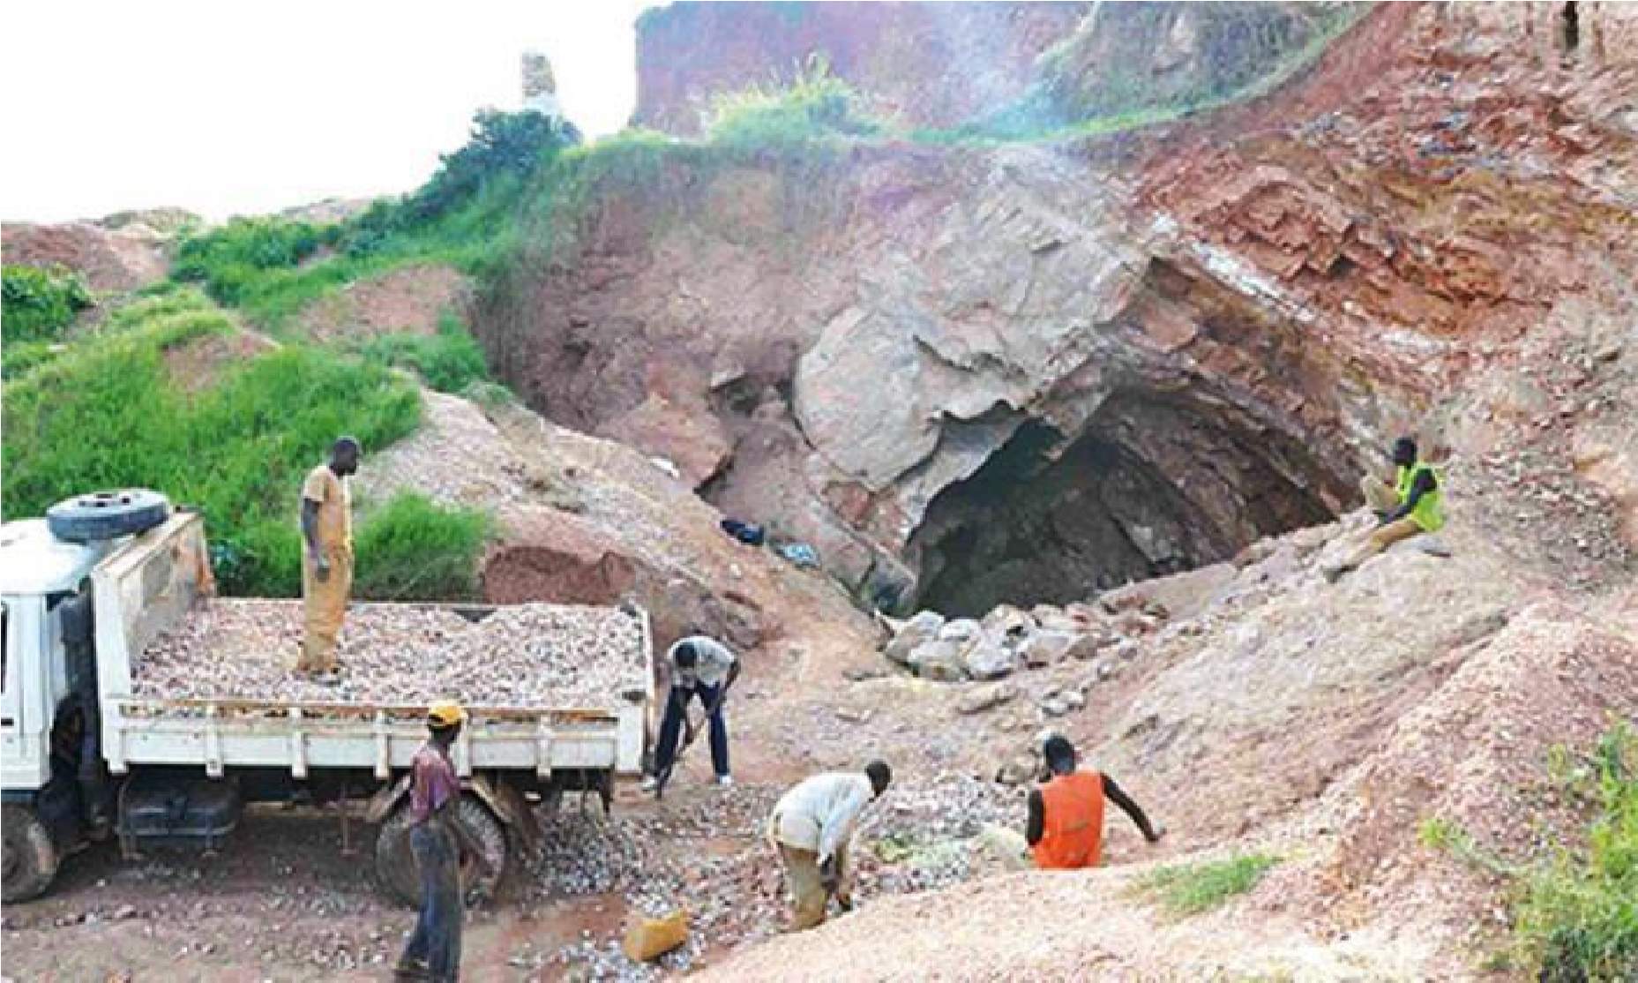

Task:
(a) (i) Draw a sketch of the area shown in the photograph provided. (4 scores)
(ii) Using the photograph provided, explain to the ministry officials the application of the mining used and the losses local communities register through using artisan mining. (8 scores)
(b) Advise the local community people on the need to accept the ministry plans on attracting foreign companies. (4 scores)

SECTION B
Part 1
Answer only one item from this part
Item 3.
A group of geologists from United Kingdom have visited East African region to research about rock materials of past tools and building and you are on a team giving guides and facilitations through explaining on different discoveries.
While visiting some area, they saw rocks having big crystals, glassy shines, very hard stone, and having no fossils. They also saw others very fine, soft particles in series of layers and have much remain of plants and animals. This increased their motives to know more information about them.
Task:
(a) Name and describe for the possible two rock types the geologists would like to know more about. (8 scores)
(b) Explain how the information of these rocks limit human activities in different parts of East Africa where they exist. (4 scores)

Item 4
Africa is a region with varied rainfall distribution showing many climatic belts. In the lower latitudes 6⁰N and 6⁰S, the belt has a belt of low pressure, thick forests and also support different crop production. People have settled in the areas within the belt.
However, due to current climatic changes, the forecasts indicates the prolonged rain pours over 1600 mm which will trigger hazards in uplands and low lands and many people have been asked to go to the resettlement camps governments have put.
You are on a survey in the areas talked about and provided with a map of Africa in Fig.1 to get information to be used in the public meetings with the people asking them to adhere to the program

Fig. 1 Map of Africa’s rainfall forecast and its distribution
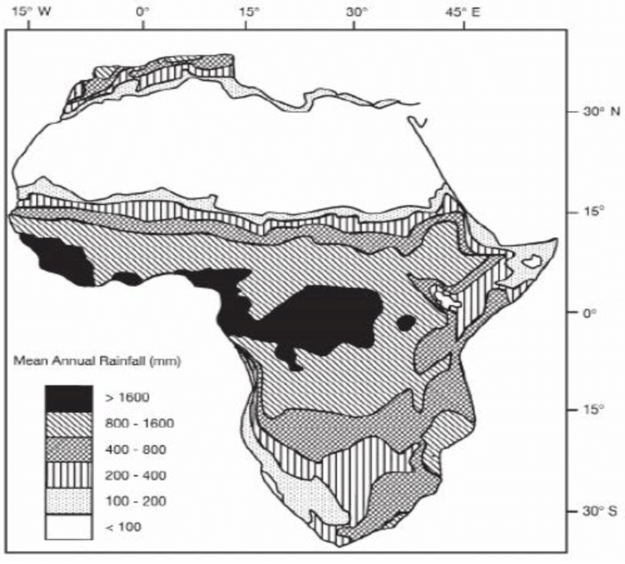
Task:
(a) Identify the region and describe its information to the people staying. (4 scores)
(b) Explain to the people the likely hazard they are to face if they do not go to the resettlement camps set by the government and advise the on the suggestions for addressing the effects to be caused. (8 scores)

Part II
Answer one item in this part
Item 5.
In African countries, many cultural practices believe in having multiple births for many children leading to high total population contributing to country’s development. In china, the one child policy in 2016 ended to allow families in china increase the population which dint bring quick results and in 2021, china amended its population and family planning law for couples have three children.
World population statistics shows total population in China is 1,418,268,586, Egypt is 117,129,538, Nigeria with 234,243,959, USA with 335,893,238, Kenya, 56787989 and Burundi 14,047786. This has contributed to difference in population density 151.00, 110.83, 236.58, 38.00, 91.33 and 547 respectively which shows levels of development the countries selected.
However, governments are against the cultural practices saying call for pressure on resources leading to depletion and wrong planning. And research also show that highly developed countries had lower population densities compared to still developing countries in Africa. These arguments conflicting caused people to approach you to explain to them the relationship between population and development
Task:
(a) Using appropriate illustration: (i) resent the population density statistics in the table (4 scores) (ii) draw a suitable graph to represent the total population for the selected countries. (4 scores)
(b) Explain the contributions of large population size to the development of any one country in the scenario and table. (4 scores)

Item 6
East Africa is one of the fastest urbanizing areas in the whole continent. From 2000 to 2018, urbanization in the region grew by 4.55%. Uganda and Burundi had the fastest growing rates compared to others in the region in the data represented in the illustration below.
This compared to the country’s population sizes in 2018; Uganda had 41,515,395, Burundi, 11934361, Kenya, 49,953,304, Tanzania, 58,090,443, and Rwanda, 13,531808. Information adapted https://www. Macrotrends.net,africaspopulation 2018.
This trend result from largely rural to urban drift with more youth moving into towns due to better social, economic and political effects than in rural areas. However many leaders expect this to cause both positive and negative effects in both rural and urban areas.

You have been invited by the leaders in your district at the headquarters up on the new declaration of your district to a level of a city to collect information from the public on the new development.
Task:
(a) Using the information in the scenario, calculate the existing urban population in the considered countries. (4 scores)
(b) Explain the effects of fastest urbanization in East African region by 2018 and advise the district leaders on curbing down the drifting of much youth from rural areas into urban areas. (8 scores)

END

Scoring Guide @ 20000/=
Contact 0745904106 or 0766720466 Waswa Keneth

